RECIPE  
Sloppy Joe’s

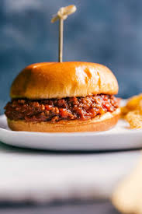

# Ingredients

* 1lb ground beef
* ⅓ green bell pepper, minced
* ½ onion, minced
* 3 cloves garlic, minced
* 1 tbsp tomato paste
* ⅔ cup ketchup
* 1 cup water
* 1 tbsp brown sugar
* 1 tsp yellow mustard
* ¾ tsp chili powder
* ½ tsp worcestershire sauce
* ½ tsp salt
* ¼ tsp red pepper flakes
* ¼ tsp pepper

# Preparation

1. In a small bowl, mix the tomato paste, ketchup, water, brown sugar, mustard, chili powder, worcestershire sauce, salt, red pepper flakes, and pepper together
2. Brown the beef and crumble it in a large saucepan
3. Add onion and bell pepper and cook until soft then add the garlic and cook for a minute or two more
4. Add the ketchup mixture to the pan, stirring to combine and cook for about 10-15 minutes until the mixture is of the desired thickness
5. Serve on burger buns, preferably slightly toasted